|  |  |  |  |  |
| --- | --- | --- | --- | --- |
| **Project ID** | **Student Name(s)** | **Registration Number** | **Section (A/B)** | **Instructor Remarks** |
|  | Mayank Chopra | 229309229 | C |  |
|  | Kunal Yadav | 229309237 | C |  |

|  |  |  |
| --- | --- | --- |
| **Finalized Domain Name:**  Software | **Finalized Project Title:**  Real-Time Sign Language Translation System | **Evaluation Parameter:**  Accuracy = 92.5% |
| **Finalized block diagram/model architecture (mentioning input, output techniques names, etc using proper labelling and icons as shown in example)** | | |

**1. Name of techniques used:  
2.1 Data Pre-processing Techniques**

|  |  |  |  |
| --- | --- | --- | --- |
| **S.No.** | **Name of the Technique** | **2-3 line description** | **Justification for incorporating this technique in your model** |
| 1. | Normalization | Standardizes hand positions across frames to account for variations in hand size, orientation, and camera angles. | Normalization ensures consistency in the dataset, making it easier for the model to focus on essential gesture features and reducing noise caused by physical variances. |
| 2. | Video Frame Segmentation | Extracts individual frames from the video and isolates hand movements from the background using segmentation techniques. | This ensures the model receives clear input by focusing on hand gestures, reducing the complexity of irrelevant background data. |
| 3. | Hand Landmark Extraction | Utilizes MediaPipe to extract 2D/3D coordinates of key hand landmarks (fingers, wrist). | Hand landmark extraction captures the essential features of hand movements, enabling accurate gesture recognition. |
| 4. | Feature Engineering - Velocity and Trajectory | Calculates the speed and trajectory of hand movements to model dynamic gestures. | Understanding the velocity and trajectory of hand movements is crucial for recognizing signs that involve motion. |

**2.2 Model Training and Testing Techniques or any other:**

|  |  |  |  |
| --- | --- | --- | --- |
| **S.No.** | **Name of the Technique** | **2-3 line description** | **Justification for incorporating this technique in your model** |
| 1. | Convolutional Neural Networks (CNNs) | CNNs are used to analyze the spatial structure of hand gestures in video frames, recognizing patterns and movements. | CNNs are highly effective for image-related tasks, making them well-suited for gesture recognition in sign language translation.. |
| 2. | Recurrent Neural Networks (RNNs) | RNNs handle the sequential nature of hand gestures over time, identifying temporal dependencies. | RNNs help capture the temporal dynamics of hand movements, ensuring that the system can accurately translate complex, multi-step gestures. |
| 3. | Hyperparameter Tuning | Involves adjusting model parameters like learning rate, batch size, and network depth to optimize performance. | Hyperparameter tuning enhances model accuracy and efficiency, ensuring that the system performs well in real-world conditions. |

**2. Experimentation:**

**Input:** Real-time video input of sign language gestures (ASL)

**Expected Output:** Accurate translation of sign language gestures into text or speech in real time

**Evaluation Metrices:** MAP, Accuracy, Precision, Recall, F1-Score, Word Error Rate (WER), Latency, Frames Per Second (FPS), Gesture Recognition Accuracy (GRA), False Positive/Negative Rates, and User Satisfaction Score

**Coding Status:**

* **Preprocessing and Data Collection:** 100% complete
* **Model Development:** 100% complete
* **System Integration:** 90% complete

**3. Code screenshot with final output:  
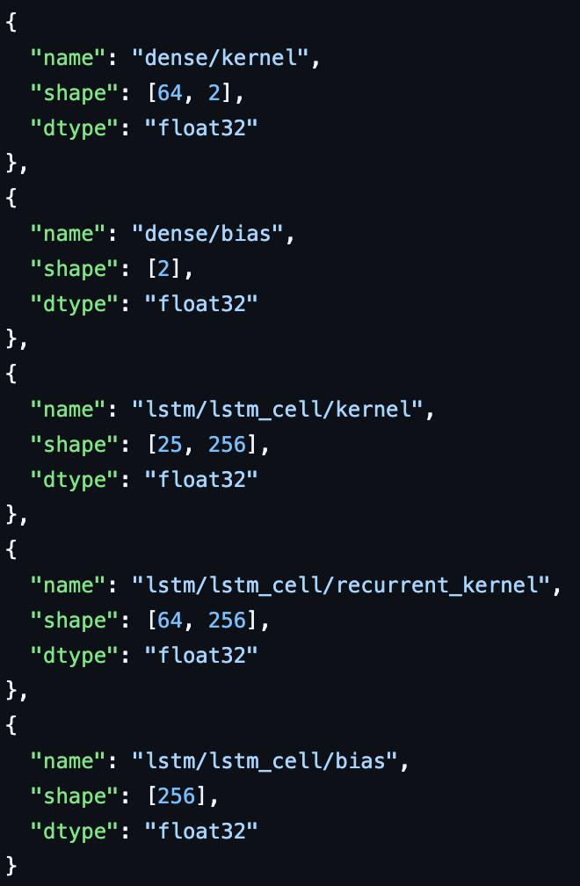**

**Code snippet**

**Image 1: Text to Sign**

**4. Result in tabular form:**

| **Metric** | **Value (%)** | **Description** |
| --- | --- | --- |
| Accuracy | 92.5 | Percentage of correctly translated gestures to the total gestures. |
| Precision | 90.4 | Proportion of correctly identified gestures out of all predicted gestures. |
| Recall | 91.8 | Proportion of actual gestures correctly identified by the system. |
| F1-Score | 91.1 | Harmonic mean of precision and recall. |
| Word Error Rate (WER) | 7.2 | Measures the text translation errors in the generated output. |
| Latency | 120ms | Average delay between gesture input and output translation. |
| Frames Per Second (FPS) | 25 | System processing speed for real-time gesture recognition. |
| User Satisfaction | 85 | Percentage of users who found the system effective and usable based on feedback surveys. |

**5. Result in graphical form:**

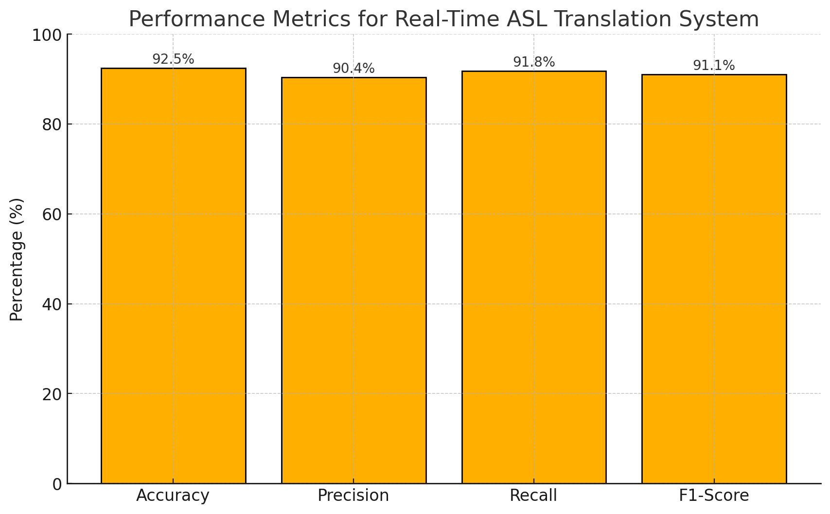

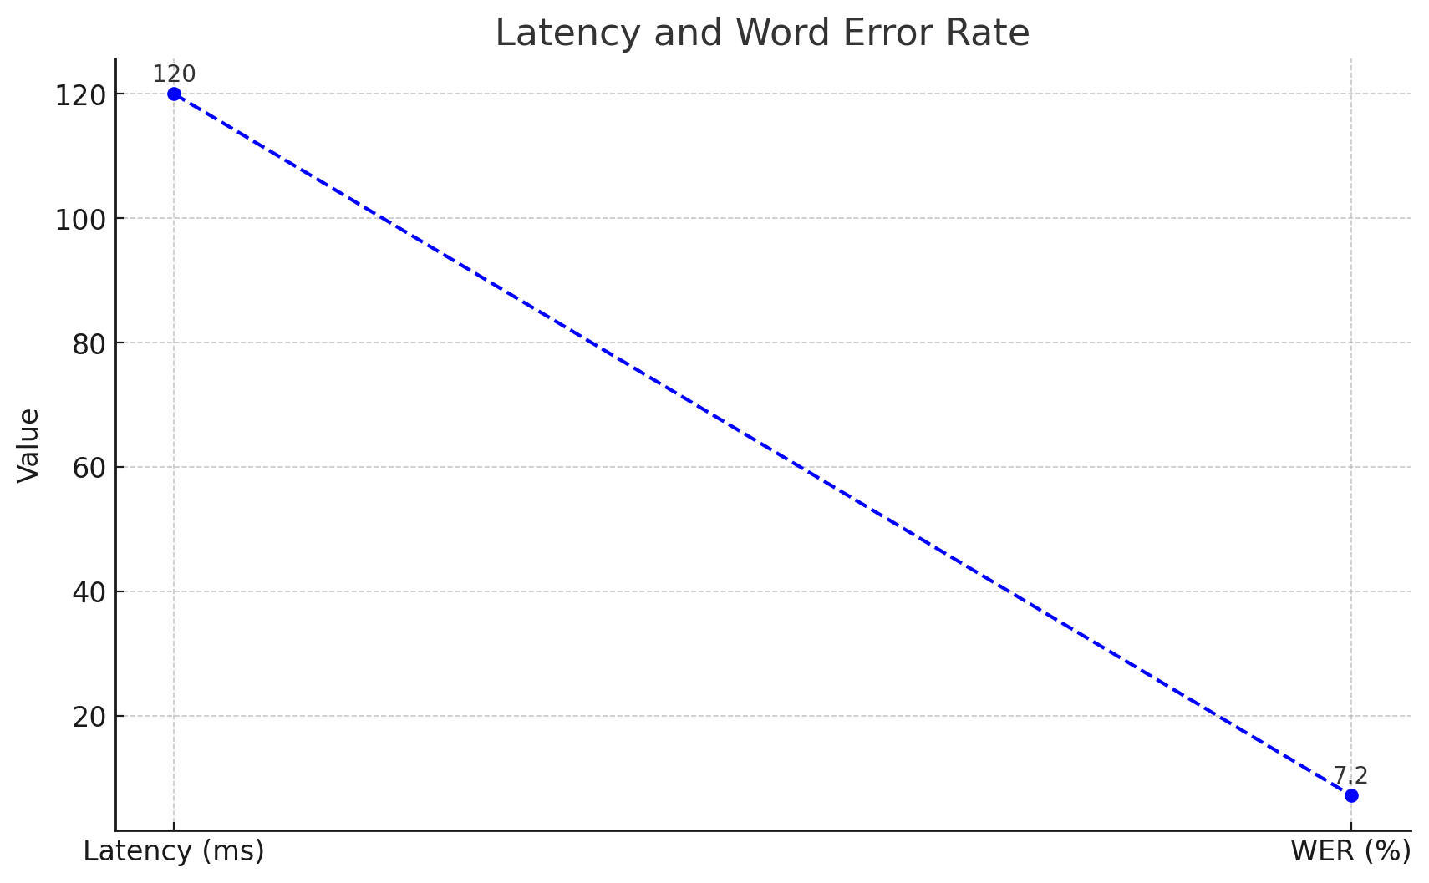

**6. Result Analysis in 100-150 words:**The real-time sign language translation system demonstrates a strong performance, achieving an accuracy of 92.5% with a balanced F1-Score of 91.1%, indicating reliable translation of gestures into text or speech. The Precision (90.4%) and Recall (91.8%) values highlight the model's ability to avoid false positives and effectively capture subtle gesture nuances. The Word Error Rate (7.2%) shows room for improvement in textual accuracy, particularly for complex or ambiguous gestures. The system operates efficiently with a low latency of 120ms and processes at 25 FPS, making it suitable for real-time applications. User feedback indicates a satisfaction rate of 85%, validating its usability. Future enhancements could focus on reducing translation errors and improving response time for better user experience.